Test Case: tc003_SPX_Dev5_Crear_Requisicion_Spot_Tipo_Cobro_CC_Urgent
Step 1 - Enter username and password and click to button Enter : Credentials Entered
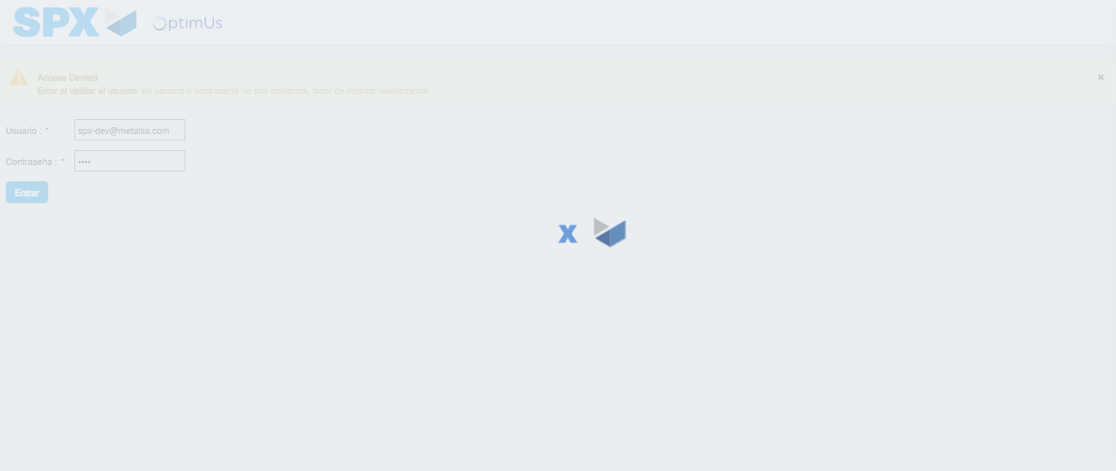Image file-name: QC_Testing-tc003_SPX_Dev5_Crear_Requisicion_Spot_Tipo_Cobro_CC_Urgent-1782240183130

Step 2 - Select to UEN and Access to Spot Buy Requisitions : UEN Correctly selected and Correct access
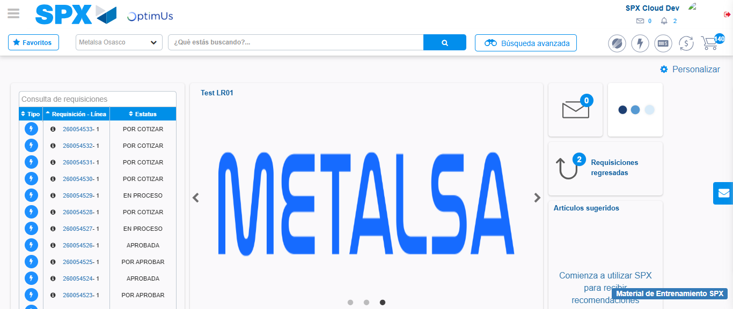Image file-name: QC_Testing-tc003_SPX_Dev5_Crear_Requisicion_Spot_Tipo_Cobro_CC_Urgent-1782240209724

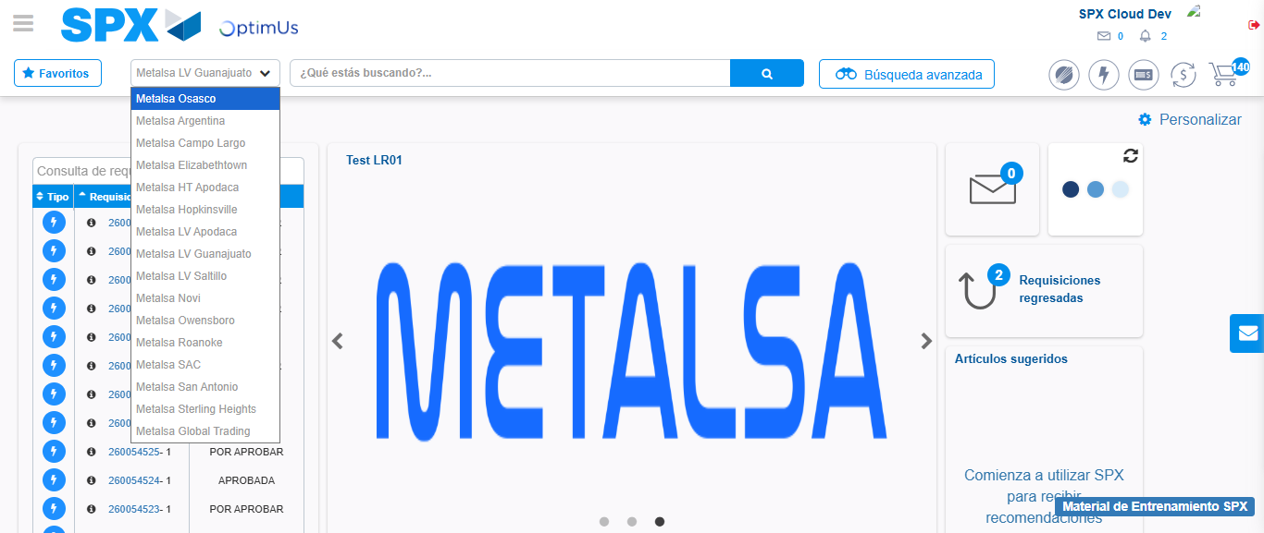Image file-name: QC_Testing-tc003_SPX_Dev5_Crear_Requisicion_Spot_Tipo_Cobro_CC_Urgent-1782240212525

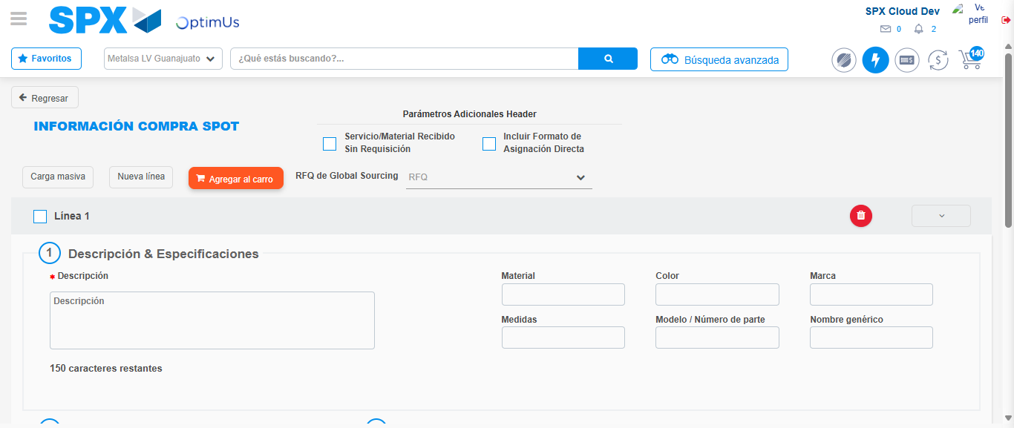Image file-name: QC_Testing-tc003_SPX_Dev5_Crear_Requisicion_Spot_Tipo_Cobro_CC_Urgent-1782240231780

Step 3 - Data Capture Spot Buy Requisition: Data captured correctly
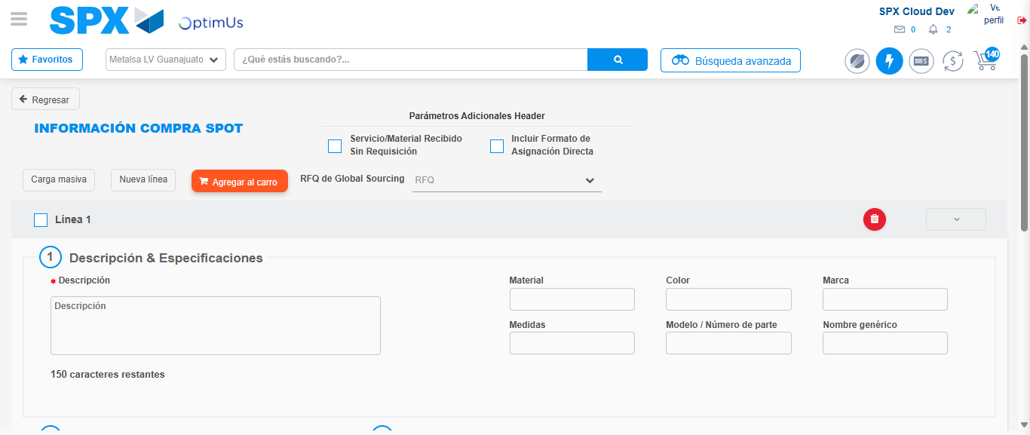Image file-name: QC_Testing-tc003_SPX_Dev5_Crear_Requisicion_Spot_Tipo_Cobro_CC_Urgent-1782240232085

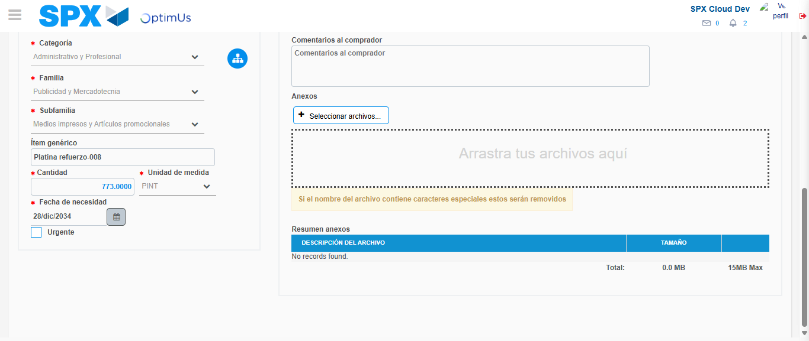Image file-name: QC_Testing-tc003_SPX_Dev5_Crear_Requisicion_Spot_Tipo_Cobro_CC_Urgent-1782240244019

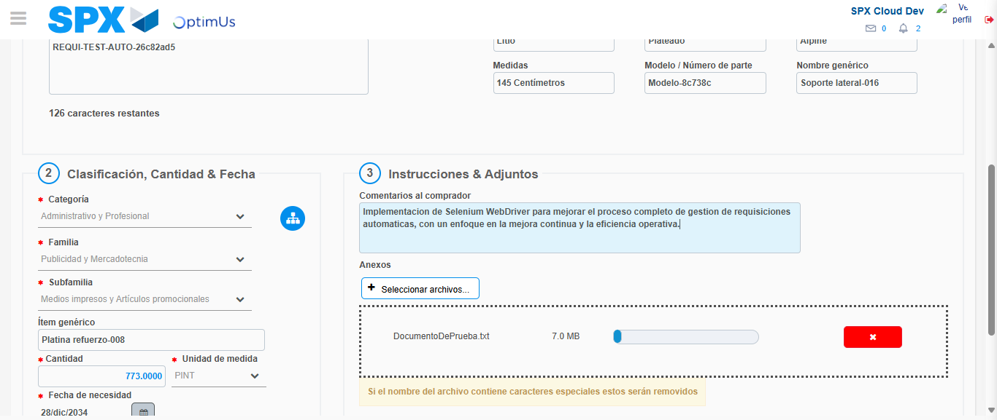Image file-name: QC_Testing-tc003_SPX_Dev5_Crear_Requisicion_Spot_Tipo_Cobro_CC_Urgent-1782240244985

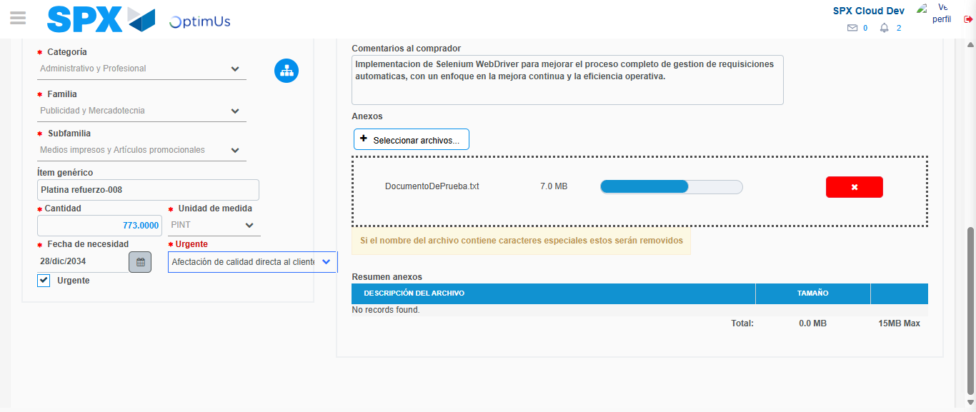Image file-name: QC_Testing-tc003_SPX_Dev5_Crear_Requisicion_Spot_Tipo_Cobro_CC_Urgent-1782240248942

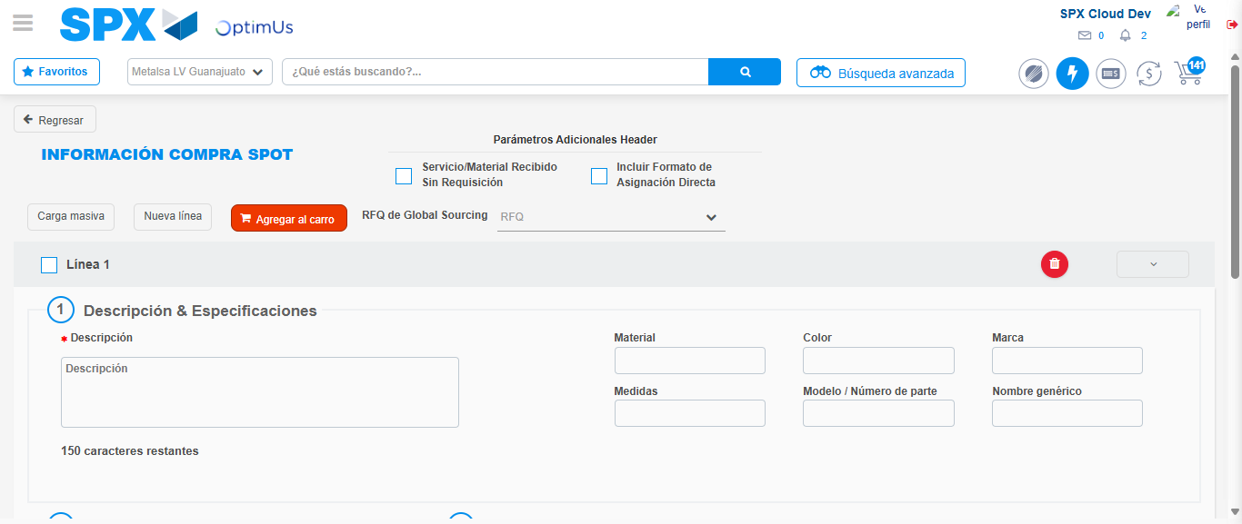Image file-name: QC_Testing-tc003_SPX_Dev5_Crear_Requisicion_Spot_Tipo_Cobro_CC_Urgent-1782240260229

Step 7 - Return to Main Page SPX : Return to Main Page SPX
Image file-name: QC_Testing-tc003_SPX_Dev5_Crear_Requisicion_Spot_Tipo_Cobro_CC_Urgent-1782240209724

Image file-name: QC_Testing-tc003_SPX_Dev5_Crear_Requisicion_Spot_Tipo_Cobro_CC_Urgent-1782240212525

Image file-name: QC_Testing-tc003_SPX_Dev5_Crear_Requisicion_Spot_Tipo_Cobro_CC_Urgent-1782240231780

Image file-name: QC_Testing-tc003_SPX_Dev5_Crear_Requisicion_Spot_Tipo_Cobro_CC_Urgent-1782240262557

Image file-name: QC_Testing-tc003_SPX_Dev5_Crear_Requisicion_Spot_Tipo_Cobro_CC_Urgent-1782240262769

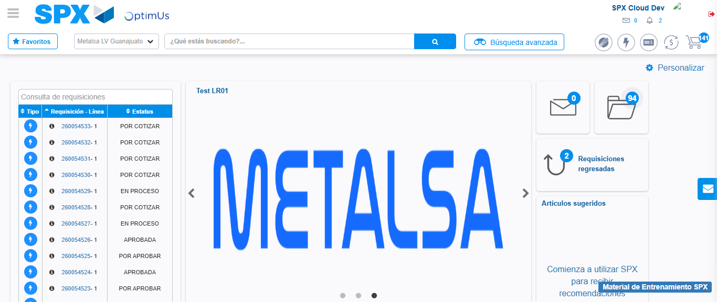Image file-name: QC_Testing-tc003_SPX_Dev5_Crear_Requisicion_Spot_Tipo_Cobro_CC_Urgent-1782240284205

Step 8 - Log Out : Log Out SPX
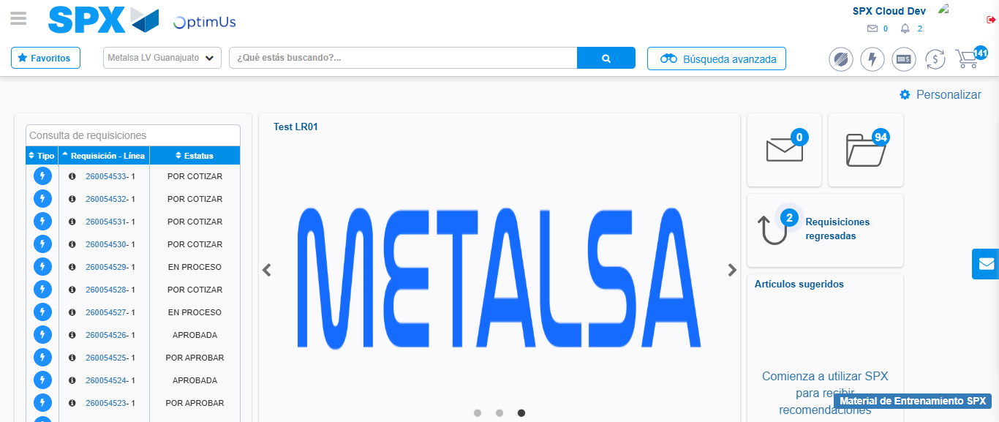Image file-name: QC_Testing-tc003_SPX_Dev5_Crear_Requisicion_Spot_Tipo_Cobro_CC_Urgent-1782240284577

